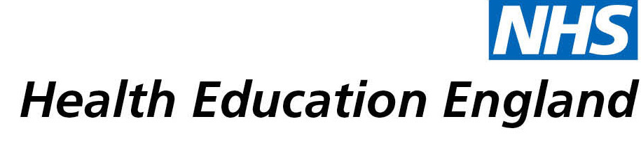

# Library and Knowledge Services case study

# *University Hospitals Birmingham LKS: Use of Acetazolamide in Pitt-Hopkins syndrome*

# *6th November 2020*

## Reason for enquiry

*A patient with Pitt-Hopkins syndrome, a very rare condition came to the Paediatric department of our hospital and the library received an evidence search request to find out if acetazolamide is a safe and effective treatment for severe episodes of hyperventilation and apnoea with this rare disorder.*

*“****A rare condition with a novel treatment I needed to know the evidence base before starting any treatment”***

## What the knowledge and library specialist did

The library and knowledge services provided a summary of evidence on the topic in a systematic manner elaborating the search strategy and hierarchy of evidence.

# Impact of input from the library and knowledge service

*The evidence search helped in taking decisions and directly impacted the patient care. It was an urgent requirement and the library carried out a comprehensive search at the right time to the right user and saved their clinical time.*

***“very prompt service, highly appreciated”****.*

## Immediate Impact

***“The patient is now on the treatment and has benefited. The results of the search helped me to implement effective treatment for a very rare condition”***

## Probable future Impact

Though it is unlikely to be further used locally in near future because of its rarity, the clinician might consider publishing a case study in future.

## Submission by:

Dr Alan Stanton

Consultant Community Paediatrician

## For further information on how you can get similar support contact your local NHS library and knowledge service.